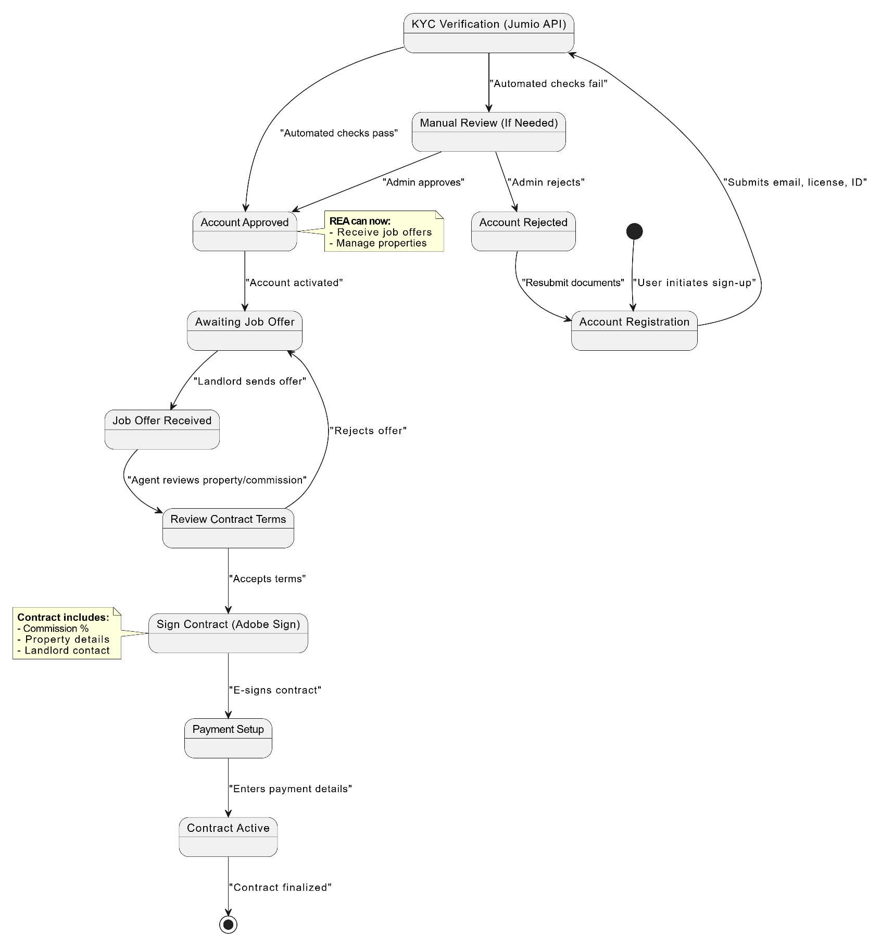

**UC_REA_01 (Account Creation)** and **UC_REA_03 (Contract Signing)**

These can be combined because the account creation process (verification, KYC) leads directly to the contract signing state when the agent is hired by a landlord. The states flow naturally from registration → verification → contract signing.

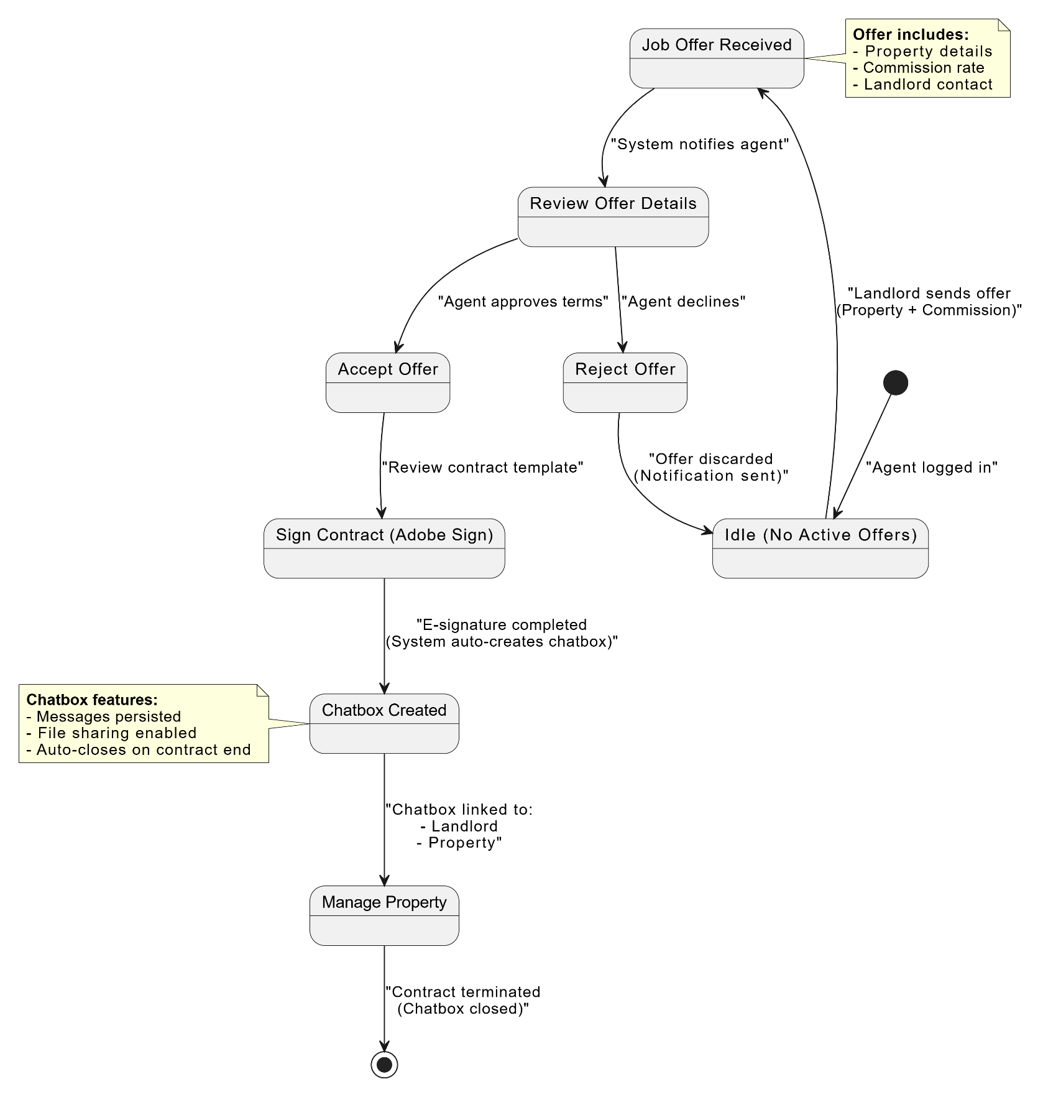

**UC_REA_02 (Job Offer Handling)** and **UC_REA_04 (Chatbox Creation)**

These can be combined because accepting a job offer (UC_REA_02) triggers the creation of a chatbox with the landlord (UC_REA_04). The states transition from "Job Offer Received" → "Accepted/Rejected" → "Chatbox Active" (if accepted).

